**Lab Report – Week 5**

CS2023 Data Structures and Algorithms

Dept. of Computer Science and Engineering, University of Moratuwa

|  |  |
| --- | --- |
| Name: Tharindu Perera | Index Number: 210472J |

|  |
| --- |
|  |
| **Question 1**  Time in milliseconds in 10 consecutive runs (average in the last column)    Code  *Helper functions*    *Recursive Quick Sort*    *Non-Recursive Quick Sort*    **Question 2** | |
| |  |  | | --- | --- | | main.cpp | | | 1 | #include <iostream> | | 2 | #include <vector> | | 3 | #include <string.h> | | 4 | #include <sstream> | | 5 |  | | 6 | using *namespace* std; | | 7 |  | | 8 | *void* insertIntoSortedArray(*vector*<*int*>& *arr*, *int* *element*) { | | 9 | *int* i = 0; | | 10 | while (i < *arr*.size() && *arr*[i] < *element*) { | | 11 | i++; | | 12 | } | | 13 | *arr*.insert(*arr*.begin() + i, *element*); | | 14 | } | | 15 |  | | 16 | *bool* stringIsInt(*string* *s*) { | | 17 | for (*int* i = 0; i < *s*.length(); i++) | | 18 | { | | 19 | if(isdigit(*s*[i])) continue; | | 20 | if (i == 0 && *s*[i]=='-') continue; | | 21 | return false; | | 22 | } | | 23 | return true; | | 24 | } | | 25 |  | | 26 | *void* print_arr(*vector*<*int*> *arr*) { | | 27 | cout << "{"; | | 28 | for (*int* i = 0; i < *arr*.size()-1; i++) { | | 29 | cout << *arr*[i] << ", "; | | 30 | } | | 31 | cout << *arr*[*arr*.size()-1] << "}"; | | 32 | } | | 33 |  | | 34 | *int* main() { | | 35 |  | | 36 | *vector*<*int*> arr = {}; | | 37 | *string* input = ""; | | 38 |  | | 39 | cout << "Enter integers one by one. Enter \"end\" to stop stream.\n\n"; | | 40 |  | | 41 | while (true) | | 42 | { | | 43 | cout << ">"; | | 44 | cin >> input; | | 45 | if (input == "end") break; | | 46 | if (!stringIsInt(input)) throw *invalid_argument*("Integer value expected. Enter end to stop stream."); | | 47 |  | | 48 | *stringstream* ss; | | 49 | *int* next; | | 50 | ss << input; | | 51 | ss >> next; | | 52 |  | | 53 | insertIntoSortedArray(arr, next); | | 54 |  | | 55 | *float* median = (arr[(arr.size() - 1) /2] + arr[arr.size() / 2]) /2.0; | | 56 |  | | 57 | cout << "Array: "; | | 58 | print_arr(arr); | | 59 | cout << "     | Median: " << median << endl << endl; | | 60 |  | | 61 | } | | 62 |  | | 63 | return 0; | | 64 | } | | 65 |  | | |

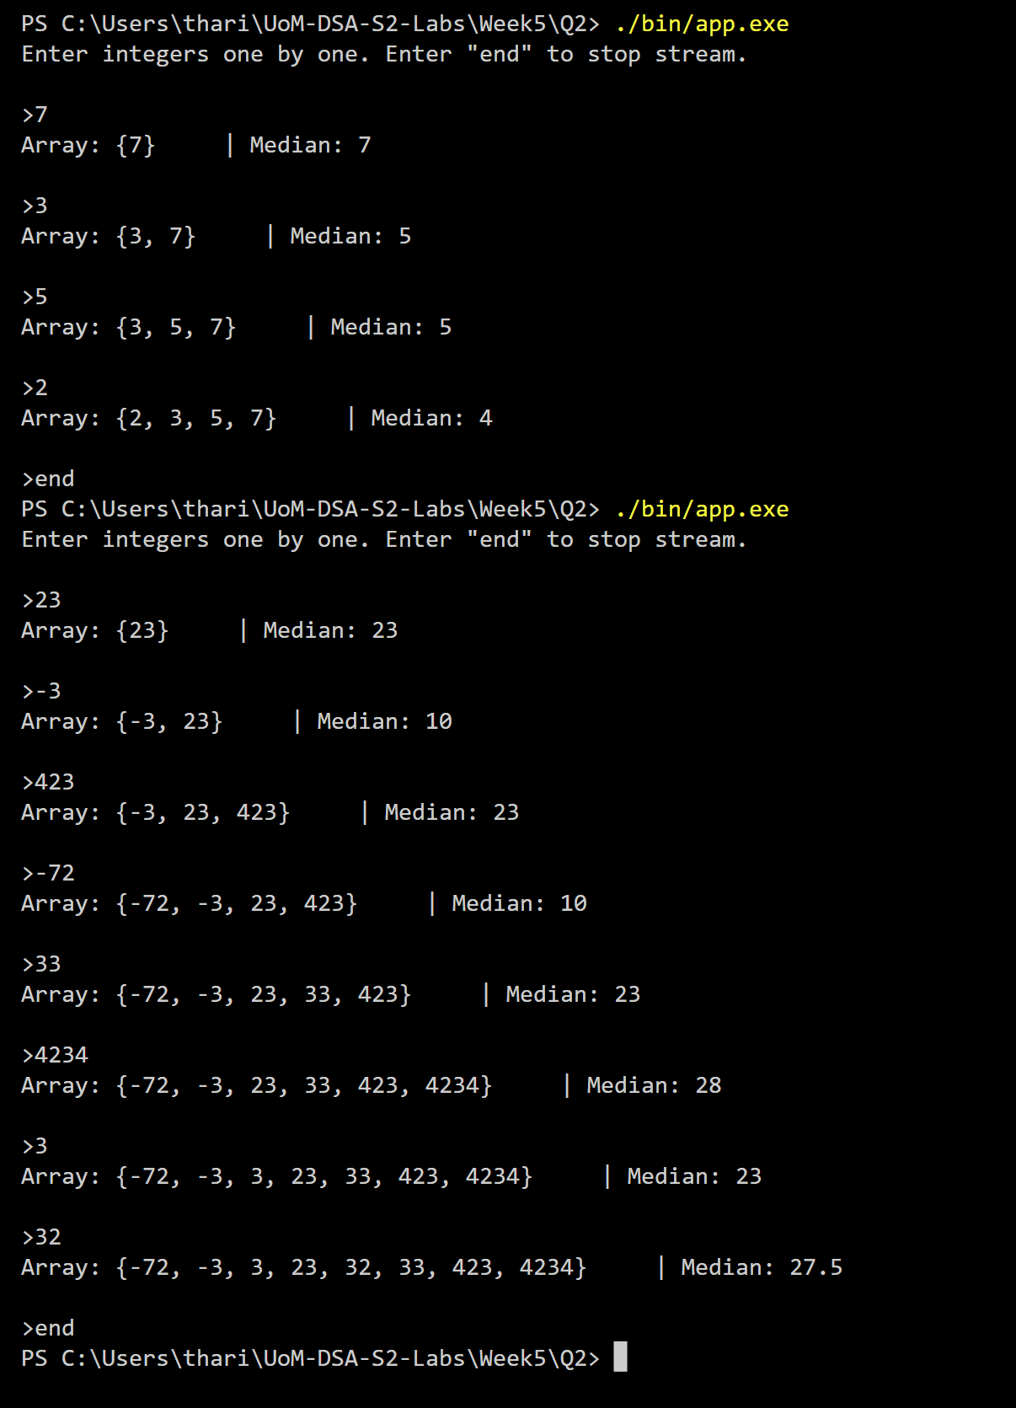

Github repo: [Tharindu6516/UoM-DSA-S2-Labs: Lab tika (github.com)](https://github.com/Tharindu6516/UoM-DSA-S2-Labs)